Learning Journal Unit 3

1. Learning Journal Reflective  Comments:

The learning Guide is being completed on Sunday, I did not realize the problem I met until I start quiz, Standard deviation is challenging for me especially the degrees of freedom concept.

The biggest problem I met in this week is when I import a dataset trying to compute the standard deviation, here comes the error.

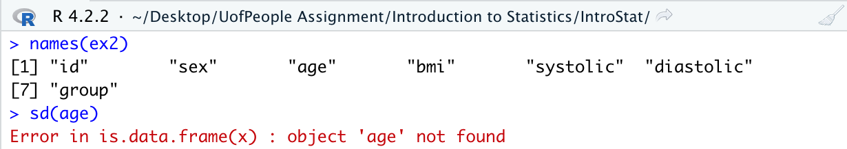

Then I search about error information in Google.

<https://www.statology.org/r-object-not-found/>

Then I realize this issue is mentioned in last Unit(Unit 2), Attaching data part.

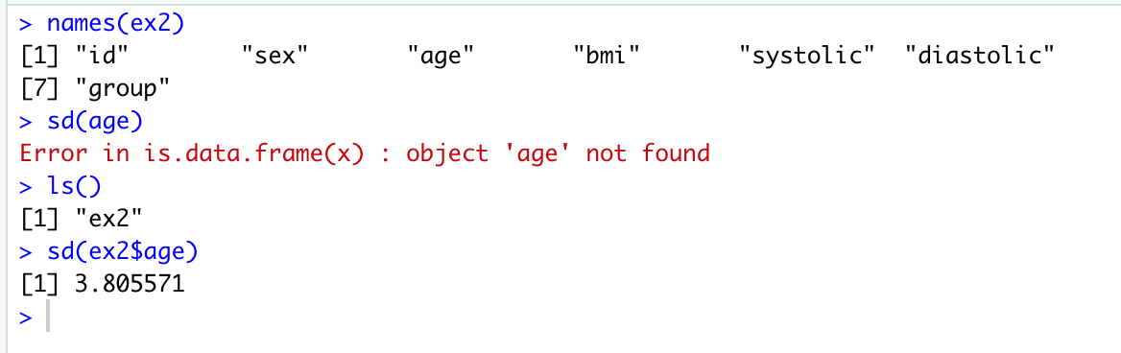

ex2 is an object, I using $ to obtain age variable in ex2. Issue solved.

Even it spends me lot of time to find out solution, but it’s worth learned from mistake and issue.

2. Vocabulary and R functions

a)

> ?length

## Length of an Object

### Description

Get or set the length of vectors (including lists) and factors, and of any other **R** object for which a method has been defined.

b)

According to 3.4 calculate result

> var(x)

[1] 0.5125

sum((x - x.bar)^2)/(length(x)-1)

[1] 0.5125

Sample variate is square standard deviation.

3. Task

I spend 2 hours per day in 4 days to complete Unit 3 learning.

I will pre-study Unit 4 tomorrow and spend extra 1 hours per day in next Unit.

Wednesday, 30 November 2022 (AEDT)

Time in Melbourne VIC

Reference:

# <https://www.statology.org/r-object-not-found/> How to Fix in R: object not found, BY zach, April 7,2022

MarinStatsLectures-R Programming & Statistics. (2013, August 8). Working with variables and data in R | R Tutorial 1.8 | MarinStatslectures [Video]. YouTube. <https://youtu.be/1BcGnHwUT6k>

Yakir, B. (2001). Introduction to statistical thinking (with R, without Calculus). The Hebrew University of Jerusalem. (pp39)